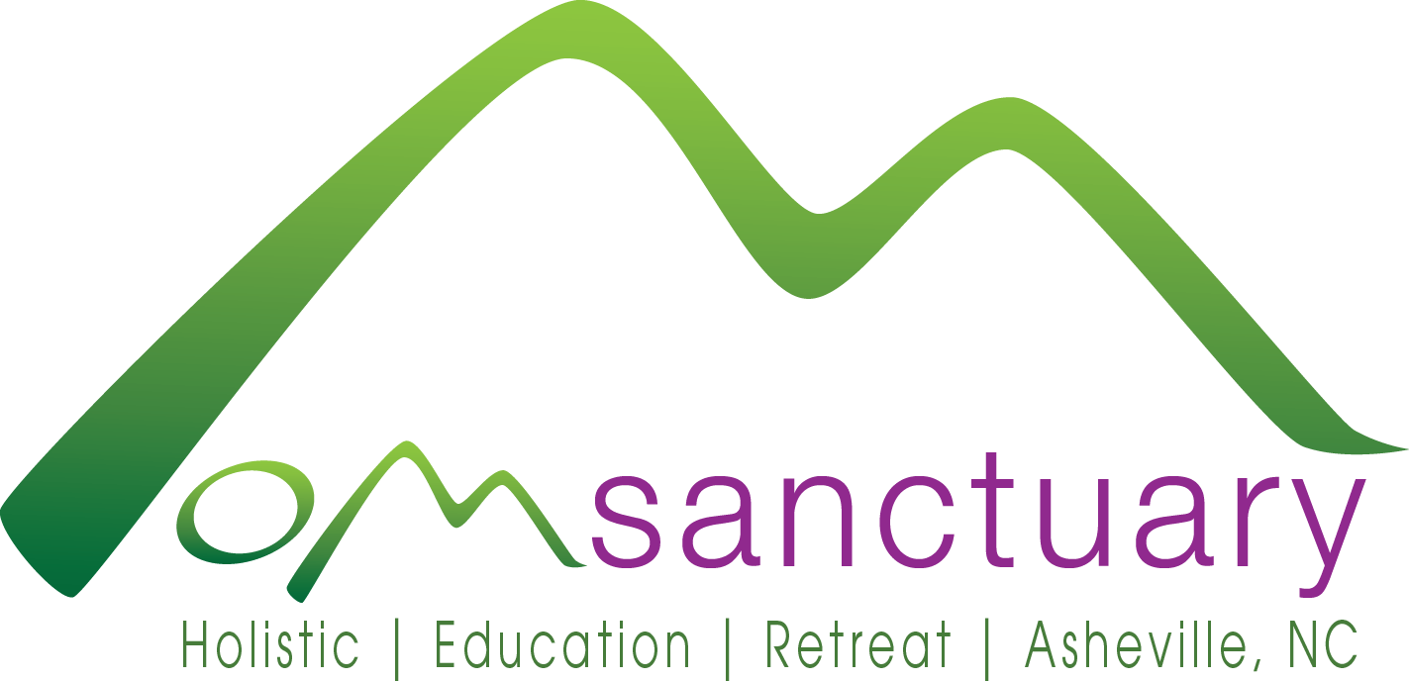
OM Sanctuary - Holistic Education Retreat
87 Richmond Hill Dr • Asheville, NC 28806 • Phone: 828.252.7313 • Website: omsanctuary.org
Press Release
For Immediate Release Contact: Shelli Stanback
May 28, 2015 828-252-7313
Email: shelli@omsanctuary.org

OM Sanctuary protects urban forest near Asheville
42 acres of mature urban forest protected by a conservation easement

Asheville, NC – After three years of dedicated effort, OM Sanctuary’s 42-acre urban forest was recently protected by a conservation easement through the Southern Appalachian Highlands Conservancy. Overlooking the French Broad River, Interstate 26, and Riverside drive, the easement protects a bluff containing cove forest, oak forest, and low montane pine forest with mixed hardwoods. The tract also contains pools in the river floodplain that provide
“We were thrilled at the opportunity to protect this undeveloped, mature forest so near the heart of the city,” said Carl Silverstein, SAHC’s Executive Director. “It is a rare gem containing an uncommon cluster of natural features near Asheville’s urban core. The forest provides ecosystem services and preserves a scenic view seen by many people every day: recreational users of the French Broad River and everyone who drives past it.”
The conservation easement at OM Sanctuary, very near Buncombe County’s Richmond Hill Park and the state-designated Richmond Hill Forest Natural Area, protects a healthy wooded tract containing cove forest, oak forest and low mountain pine forest, with mixed hardwoods. The tract also contains pools in the river floodplain that provide likely habitat for wildlife like salamanders, amphibians, and reptiles. Conservation of the property helps protect tributary streams of the French Broad River Watershed from sources of sedimentation and other types of pollution. OM Sanctuary will continue to use existing hiking trails through the protected forest in fulfilling their mission to inspire healthy lifestyle practices through holistic education and connection with nature.
“Natural places are essential for human health,” says Shelli Stanback, OM Sanctuary Founder and President. “Once they have been lost to development, they are gone forever. We must preserve them now for our sake, and for the sake of the future. With few urban open spaces remaining near Asheville, protecting the forest with a conservation easement was the clear, sustainable choice.”
Celebration and public announcement of the new conservation easement will be held in conjunction with an open house event at OM Sanctuary on Saturday, June 6.
About OM Sanctuary:
This non-profit organization was formed in 2012 as a response to the increasing number of people of all ages, cultures, and income levels seeking holistic methods to improve health, reduce stress, and bring balance to their personal and professional lives. Located on the site of the historic Richmond Hill hotel just outside downtown Asheville, NC, OM Sanctuary responds to this need by offering a holistic retreat center, educational scholarship programs, and charitable initiatives focused on Body, Mind, Spirit, and Nature. Their mission is to inspire healthy lifestyle practices through holistic education and connection with nature. For more information, visit http://www.omsanctuary.org.
About Southern Appalachian Highlands Conservancy:
Since 1974, the Southern Appalachian Highlands Conservancy has protected over 68,000 acres of unique plant and animal habitat, clean water, farmland and scenic vistas of the mountains of North Carolina and Tennessee for the benefit of present and future generations. In addition to preserving land, their conservation work includes guided hikes, volunteer workdays, educational workshops, and farmland access initiatives. For more information, visit www.appalachian.org.
###

